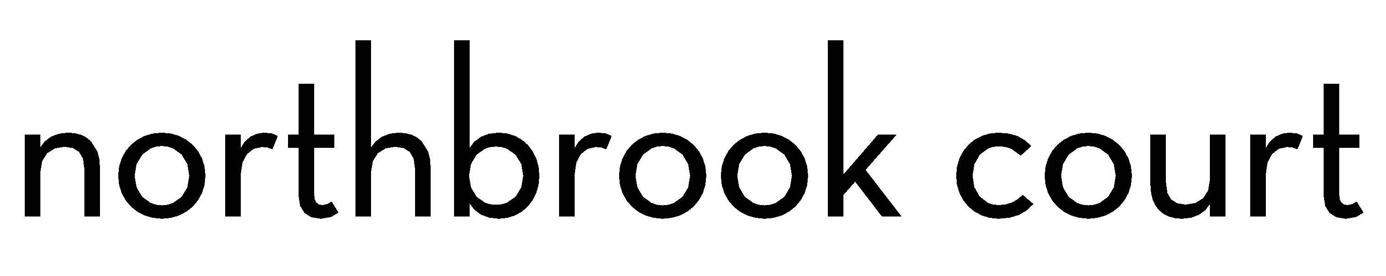

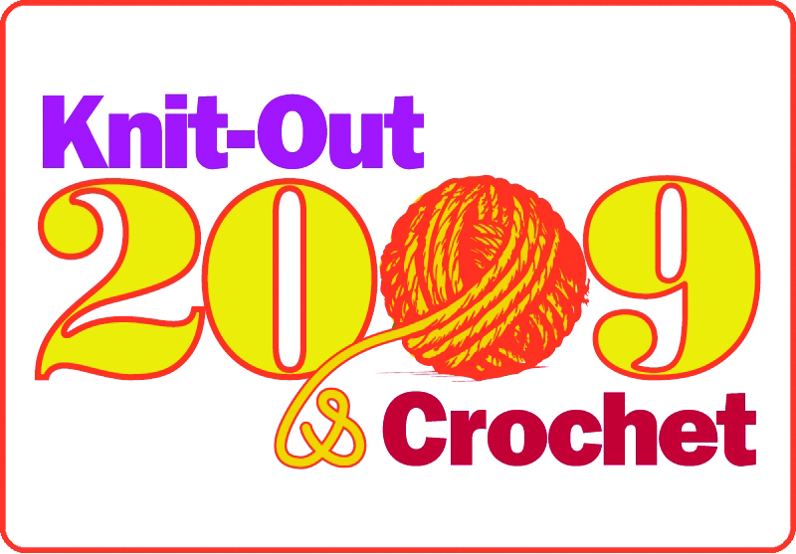

Northbrook Court to Host Knitting and Crocheting Event

The first Knit-Out and Crochet event in Illinois will take place at Northbrook Court, Saturday, April 18, from 10 a.m. until 4:00 p.m. Already popular in Minneapolis and New York, this event is intended to enhance the center’s shopping experience for visitors, while increasing the awareness and knowledge of knitting and crocheting as an art form and craft.

The 2009 Knit-Out and Crochet event will be hosted by Prairie Arts and Fibers of Grayslake and Three Bags Full of Northbrook. Participating stores include Closeknit of Evanston, Magic Needle of Highland Park, Montoya Fiber Studio of Evanston and Studio Beads of Deerfield. Volunteers will be provided by Prairie Knitter’s Knitting Guild and Fox Valley Knitting Guild.

A full day of fun and educational activities are planned with something for everyone-from beginners to advanced enthusiasts. Here is the schedule:

10:00 a.m.- 4:00 p.m. Items from shops on display

10:00 a.m.- 4:00 p.m. Continuous classes (various levels of experience)

10:30 a.m.- 12:30 p.m. Special technique demonstrations

11:00 a.m.- 4:00 p.m. Door Prize Drawings

1:00 p.m.- 1:30 p.m. Fastest knitter and crocheter competitions

2:00 p.m.- 2:30 p.m. Fashion Show

3:00 p.m.- 3:30 p.m. Author Amy Singer presentation

3:30 p.m.- 4:00 p.m. Author Amy Singer book signing

There will also be a charity component to the 2009 Knit-Out where Northbrook Court shoppers and visitors may bring in 7 inch by 9 inch squares (washable wool or soft acrylic) or make them on site for the completion of a blanket to be donated to Habitat for Humanity. For more information on the event, please contact Denise Bein at 847-543-5255 or denise@prairieartsandfibers.com.

